WaterX@2022 International Workshop May 30 - June 4 2022

Title of Contribution

Name
affiliation
Insert here your text Insert here your text Insert here your text Insert here your text Insert he re your Insert here your text Insert here your text Insert here your text Insert here your text In sert here your text Insert here your text Insert here your text Insert here your text Insert here

[1] R.J. Speedy, J. Phys. Chem. 1982, 86, 982−991.
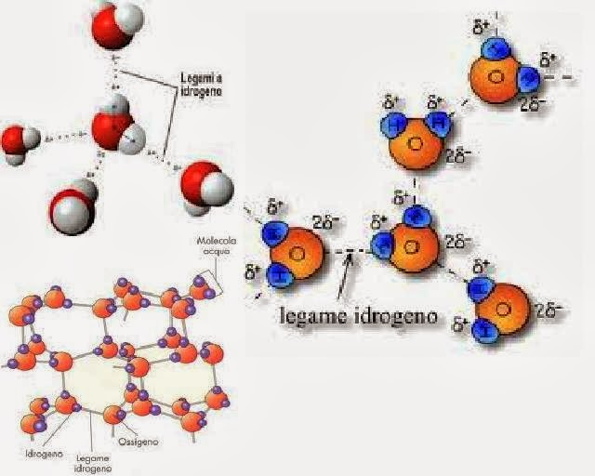
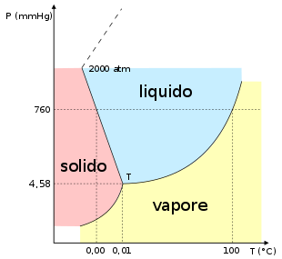

Questa foto di Autore sconosciuto è concesso in licenza da CC BY

Questa foto di Autore sconosciuto è concesso in licenza da CC BY-SA

Figure caption

